Hospital Database

By: Shahzan Tariq (0785469) and Mariam Merza (0763480)

Abstract
This project focuses on designing a robust database system by following a systematic approach. It involves the creation of a database model, conversion to relational data, and implementation of SQL queries. The outlined steps encompass:

- Data Item Selection: Determining the data items to be stored.
- Entity Identification: Identifying entities and their attributes.
- Attribute Definition: Defining data types for each attribute.
- Relationship Establishment: Establishing relationships between entities, including weak entities, recursive relationships, and class hierarchies.
- Model Creation: Developing a UML or ER model for the database.
- Relational Data Model: Converting the model into a relational data schema with primary and foreign keys across 6-8 tables.
- Query Design: Crafting SQL queries to meet specified requirements, including single-table, two-table, and three-table queries.
- SQL Implementation: Executing SQL commands to create tables, input data, and showcase the output through screenshots of the executed queries.

This project presents a structured approach to database design and implementation, demonstrating a comprehensive understanding of database modeling, schema creation, and SQL query construction.

Table of Contents

Introduction

Data Item Selection

Entity Identification

Attribute Definition

Relationship Establishment

Model Creation
Query Design

SQL Implementation
Conclusion

Dataset References

Introduction
The healthcare industry relies heavily on efficient management of information, resources, and patient care. In response to this need, this database system has been designed to streamline the operations within a healthcare facility. This database encompasses multiple interconnected tables to facilitate the management of hospitals, medical professionals, patients, appointments, and medical equipment.

The core components within the database include the following tables:

Hospital: Captures essential information about hospitals, including their unique identification, name, location, and ratings.

Doctor: Details the profiles of medical practitioners, including specialization, affiliations with hospitals, and supervisory relationships within the medical staff.

Patient: Stores information related to patients, such as identification, age, and contact information.

Appointment: Manages appointments by recording dates, assigned rooms, associated doctors, and linked patients.

Equipment: Catalogs medical equipment with crucial details such as identification, name, manufacturer, manufacturing year, quantity, and hospital associations.

Imaging and Surgical: Subclass tables under Equipment, imaging and surgical delineate specific types of medical devices, their functionalities, resolutions, and replacement dates.

This database aims to optimize healthcare operations, enhance patient care, and enable efficient resource allocation by providing a streamlined platform for information management and coordination within healthcare facilities.

Data Item Selection

This database encompasses a comprehensive set of data items across multiple tables, each playing an important role in managing and organizing information within the healthcare system.

Hospital Information:

Hospital_ID, Name, Location, Rating: Hospitals are uniquely identified by their IDs and characterized by their names, locations, and ratings. This data allows efficient categorization and evaluation of healthcare facilities.

Doctor Profiles:

Doctor_ID, Name, Specialization, Hospital_ID, Supervisor_ID: Doctors are identified through unique IDs and detailed with their names, specializations, and affiliations with hospitals. Supervisor relationships are established, aiding in the structure of medical staff.

Patient Details:

Patient_ID, Name, Age, Phone_Num: Patients are uniquely identified and cataloged with their age, name, and contact information, crucial for effective communication and patient management.

Equipment Inventory:

Equipment_ID, Name, Manufacturer, ManufacturedYear, Amount, Hospital_ID: Medical equipment is carefully recorded, specifying IDs, names, manufacturers, manufacturing years, quantities, and hospital associations. This data facilitates efficient tracking and allocation of medical resources.

Equipment Specifics - Imaging and Surgical:

ImagingType, Resolution, SurgicalType, ReplacementDate: Differentiating characteristics of imaging and surgical equipment are stored, detailing their imaging capabilities, resolutions, types, and replacement schedules. This information aids in selecting the appropriate tools for medical procedures.

Appointment Records:

Appointment_ID, Date, Room, Doctor_ID, Patient_ID: Appointments are organized by unique IDs, dates, assigned rooms, associated doctors, and linked patients, streamlining the scheduling and management of medical consultations.

Each data item is chosen to facilitate seamless operations within the healthcare facility, ensuring effective management of resources, streamlined patient care, and optimized medical procedures. Below are the exact data items used in the database.

Hospital_ID Name Location Rating
1 City Hospital New York, USA 4.7
2 Medical Center London, UK 4.5
3 Community Health Center San Francisco, USA 4.2
4 Central Hospital Paris, France 4.9
5 Metropolitan Hospital Tokyo, Japan 4.6
6 Regional Medical Center Sydney, Australia 4.3
7 Health First Clinic Toronto, Canada 4.8
8 Sunset General Hospital Los Angeles, USA 4.4

Doctor_ID Name Specialization Hospital_ID Supervisor_ID
1 Dr. Sarah Adams Cardiologist 1 NULL
2 Dr. Mark Johnson Pediatrician 2 1
3 Dr. Emma Garcia Neurologist 3 NULL
4 Dr. Michael Brown Surgeon 4 3
5 Dr. James Lee Orthopedic Surgeon 5 NULL
6 Dr. Samantha RobertsDermatologist 6 5
7 Dr. Lucas Baker Pediatrician 7 NULL
8 Dr. Emma Foster Psychiatrist 8 7

Patient_ID Name Age Phone_Num
1 John Smith 45 +1234567890
2 Emily Johnson 30 +1987654321
3 Sophia Anderson 28 +1122334455
4 Oliver Wilson 50 +9988776655
5 Liam Miller 35 +447700112233
6 Ava Brown 24 +61400998877
7 Noah Garcia 42 +1234001122
8 Mia Wilson 60 +18005556666

Equipment_ID Name Manufacturer Manufactured Year Amount Hospital_ID
1 MRI Scanner ABC Medical 2020 3 1
2 X-Ray Machine XYZ Healthcare 2019 2 2
3 Ultrasound Machine MedTech Solutions 2021 4 3
4 Bob SurgiEquip 2018 6 4
5 CT Scanner MediScan 2022 3 5
6 Endoscopy Tower EndoTech 2020 4 6
7 Table AnesLife 2023 5 7
8 Cutter ElectroEquip 2019 7 8

Equipment_ID ImagingType Resolution
1 MRI High Definition
2 X-Ray Standard Resolution
3 Ultrasound Digital Imaging
5 CT Scan Enhanced Imaging
6 Endoscopy High Definition

Equipment_ID SurgicalType ReplacementDate
4 Surgical Robot 2023-05-15
7 Operating Table 2024-01-20
8 Scalpel 2023-04-05

Appointment_ID Date Room Doctor_ID Patient_ID
1 2023-12-10 09:00:00 101 1 1
2 2023-12-15 10:30:00 205 2 2
3 2023-12-18 11:15:00 302 3 3
4 2023-12-20 14:00:00 104 4 4
5 2023-12-22 08:45:00 402 5 5
6 2023-12-25 16:30:00 201 6 6
7 2023-12-28 13:45:00 301 7 7
8 2023-12-30 12:00:00 103 8 8

Entity Identification
- Hospital: Represents distinct medical facilities, each uniquely identified within the system. Hospitals contain essential attributes such as name, location, and rating, serving as central hubs for medical operations and patient care.

- Doctor: Individual medical professionals are categorized within the system, each uniquely identified. Doctor entities hold attributes such as name, specialization, affiliations with hospitals, and a supervisor relationship, which enables the hierarchical structure among medical staff.

- Patient: Individuals seeking medical care, uniquely identified within the system. Patient entities contain critical details such as names, ages, and contact information, essential for managing appointments and providing personalized care.

- Appointment: A pivotal entity which manages scheduled medical interactions. Appointments are uniquely identified within the system and encompass attributes such as date, assigned room, associated doctor, and linked patient. The assignment table facilitates the organization and coordination of medical consultations and treatments.

- Equipment (Superclass): A superclass entity encompassing various medical apparatus. It contains common attributes like Equipment_ID, Name, Manufacturer, ManufacturedYear, Amount, and Hospital_ID, establishing relationships with hospitals where the equipment is located.

- Imaging (Subclass of Equipment): A specialized type of medical equipment falling under the superclass 'Equipment.' Imaging devices have distinct attributes such as ImagingType and Resolution, specifying their imaging capabilities and quality.

- Surgical (Subclass of Equipment): Another specialized type of equipment within the superclass 'Equipment.' Surgical apparatus includes attributes like SurgicalType and ReplacementDate, distinguishing them by their specific surgical functionalities and replacement schedules.

Attribute Definition
Listed below are the various entities of the hospital database and their corresponding attributes.

Hospital:

Hospital_ID: INT
Reasoning: An integer type is chosen to uniquely identify each hospital. INT ensures numerical uniqueness and efficient indexing for quick retrieval.

Name: VARCHAR(100)
Reasoning: VARCHAR allows for variable length text storage, accommodating diverse hospital names without excessive space allocation.

Location: VARCHAR(100)
Reasoning: Similar to the name attribute, using VARCHAR facilitates flexible storage for varying lengths of location data.

Rating: FLOAT
Reasoning: FLOAT is selected to accommodate the precision of the hospital's rating. It enables storage of decimal values representing the rating score.

Doctor:

Doctor_ID: INT
Reasoning: Similar to Hospital_ID, an integer type is chosen for the unique identification of doctors.

Name: VARCHAR(100)
Reasoning: VARCHAR allows for flexibility in storing variable-length doctor names without imposing excessive character limitations.

Specialization: VARCHAR(100)
Reasoning: Similar to other textual attributes, using VARCHAR accommodates various lengths of specialization details.

Hospital_ID: INT, Supervisor_ID: INT
Reasoning: INT data type is used for linking doctors to hospitals and their supervisors, ensuring numerical reference integrity.

Appointment:

Appointment_ID: INT
Reasoning: INT is used for unique identification of appointments, ensuring efficient indexing and reference.

Date: DATETIME
Reasoning: DATETIME data type accurately stores date and time information, crucial for appointment scheduling.

Room: INT, Doctor_ID: INT, Patient_ID: INT
Reasoning: INT is chosen for room allocation and linking doctors and patients to appointments, ensuring numerical reference integrity.

Patient:

Patient_ID: INT
Reasoning: Similar to other ID fields, INT is selected for unique patient identification.

Name: VARCHAR(100), Age: INT, Phone_Num: VARCHAR(20)
Reasoning: VARCHAR accommodates variable-length names and phone numbers, while INT stores the patient's age numerically.

Equipment:

Equipment_ID: INT
Reasoning: INT serves as a unique identifier for all types of equipment, ensuring reference integrity across tables.
Name: VARCHAR(100)
Reasoning: VARCHAR allows for variable-length storage of equipment names, accommodating diverse naming conventions without excessive space allocation.

Manufacturer: VARCHAR(100)
Reasoning: Similar to the equipment name, VARCHAR facilitates flexible storage for varying lengths of manufacturer details, catering to different manufacturer names.

ManufacturedYear: INT
Reasoning: INT is selected to represent the year the equipment was manufactured. Using an integer type simplifies storage and retrieval of the manufacturing year as a numerical value.

Amount: INT
Reasoning: INT is used to represent the quantity of each equipment item available in the inventory. Using an integer type ensures precise numerical representation without fractional quantities.

Hospital_ID: INT
Reasoning: INT data type is used to establish a relationship between equipment and hospitals. It allows for numerical reference integrity, indicating the hospital associated with each piece of equipment.

Imaging (Subclass of Equipment):

Equipment_ID: INT
Reasoning: INT serves as a unique identifier for imaging equipment, ensuring reference integrity. It aligns with the superclass's Equipment_ID, enabling seamless connections between different types of equipment.

ImagingType: VARCHAR(50)
Reasoning: VARCHAR accommodates variable-length imaging types, allowing flexibility for different kinds of imaging technologies and their names.

Resolution: VARCHAR(20)
Reasoning: VARCHAR is chosen for resolution attributes to store details about the imaging quality. The fixed length allows for concise storage of resolution information.

Surgical (Subclass of Equipment):

Equipment_ID: INT
Reasoning: Similar to Imaging, INT is used as a unique identifier for surgical equipment, ensuring reference integrity across tables.

SurgicalType: VARCHAR(50)
Reasoning: VARCHAR accommodates variable-length surgical equipment types, allowing flexibility for storing different surgical tool names and types.

ReplacementDate: DATETIME
Reasoning: DATETIME is used to accurately store the replacement dates for surgical equipment. It ensures precision in recording when the equipment needs replacement or maintenance.

Relationship Establishment
This database establishes several crucial relationships that connect the entities, enabling data interactions within the healthcare management system. The 'Appointment' entity is a weak entity that relies on the 'Doctor' entity, forming a composite key association. Furthermore, a recursive relationship is evident within the 'Doctor' entity, where supervisors are linked recursively to doctors, outlining hierarchical supervision structures. Additionally, a class hierarchy is defined, presenting 'Equipment' as the superclass, and 'Imaging' and 'Surgical' as subclasses, each specializing in distinct medical tools.

The Hospital table exhibits a one-to-many relationship with 'Doctor,' indicating that hospitals can have one or multiple doctors associated with them. Similarly, hospitals maintain a one-to-many relationship with 'Equipment,' reflecting the varied inventory of medical tools associated with each hospital.

The Doctor table holds a one-to-many relationship with 'Appointment,' illustrating that doctors may have multiple appointments scheduled. The 'Doctor' entity also exhibits a recursive association, where supervisors, who are also doctors, are linked back to other doctors within the same entity.

The Patient table maintains a one-to-many relationship with 'Appointment,' denoting that patients can have multiple appointments scheduled for their care.

Model Creation
The following UML diagram offers a visual representation of the database schema for the healthcare management system. This diagram outlines the structural relationships between entities, showcasing the relationships and dependencies among hospitals, medical professionals, patients, appointments, and medical equipment. Each element within the diagram reflects the attributes and associations established within the database, presenting a comprehensive overview of the data model. Refer to the diagram below for a visual illustration of the database schema, aiding in understanding the organizational framework and relationships within the healthcare database.

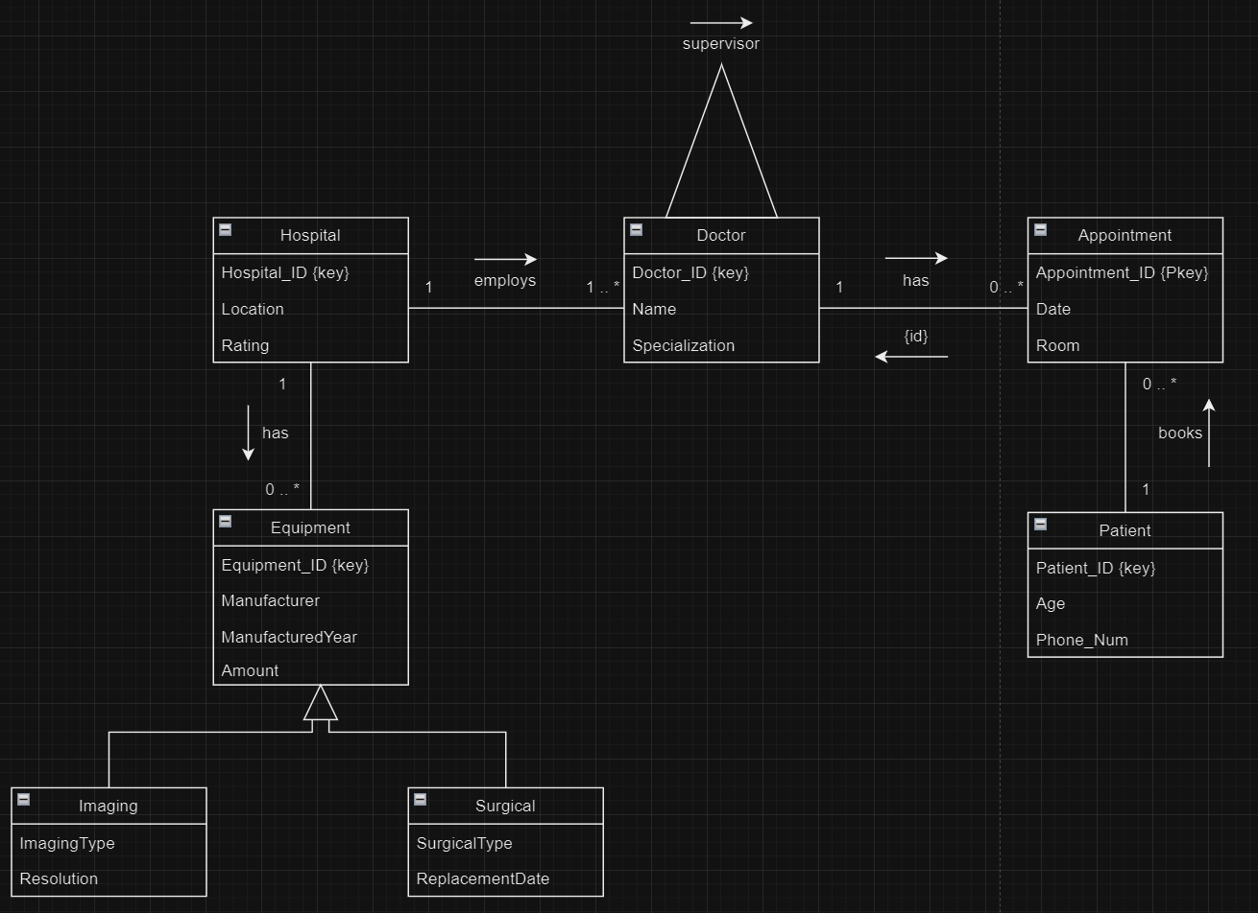

Having visualized the database structure through the UML diagram, the subsequent section presents the database schemas derived from the outlined model. These schemas highlight the logical representation of the database design, showcasing the tables, their foreign keys, primary keys, and relationships. The schemas offer a more detailed view of the database structure, allowing for a comprehensive understanding of how entities are organized and interconnected. Proceed to explore the database schemas below for an in-depth insight into the underlying architecture of the healthcare management system.

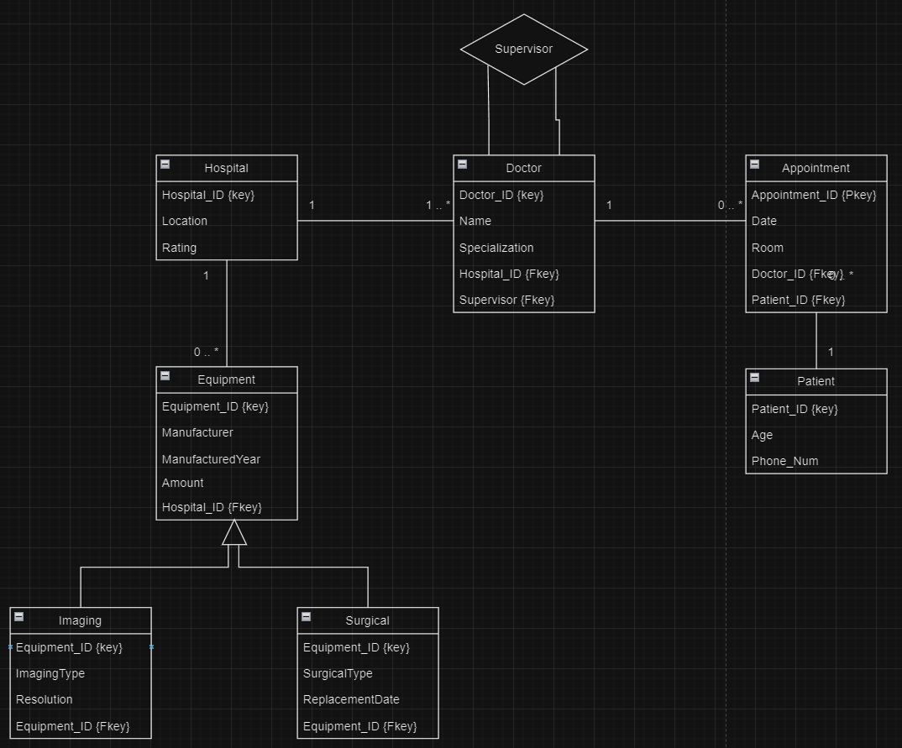

SQL Implementation
Below is the written code for the hospital database. For each entity, we begin by first creating the table and inserting each attribute, specifying its appropriate data type. Primary keys and foreign keys are identified and indicated within each table. Then, a list of data items is inserted into each table, providing values under each column.

Hospital Table
CREATE TABLE Hospital (
Hospital_ID INT PRIMARY KEY,
Name VARCHAR(100),
Location VARCHAR(100),
Rating FLOAT
);
INSERT INTO Hospital (Hospital_ID, Name, Location, Rating)
VALUES
(1, 'City Hospital', 'New York, USA', 4.7),
(2, 'Medical Center', 'London, UK', 4.5),
(3, 'Community Health Center', 'San Francisco, USA', 4.2),
(4, 'Central Hospital', 'Paris, France', 4.9),
(5, 'Metropolitan Hospital', 'Tokyo, Japan', 4.6),
(6, 'Regional Medical Center', 'Sydney, Australia', 4.3),
(7, 'Health First Clinic', 'Toronto, Canada', 4.8),
(8, 'Sunset General Hospital', 'Los Angeles, USA', 4.4);

Doctor Table
CREATE TABLE Doctor (
Doctor_ID INT PRIMARY KEY,
Name VARCHAR(100),
Specialization VARCHAR(100),
Hospital_ID INT,
Supervisor_ID INT,
FOREIGN KEY (Hospital_ID) REFERENCES Hospital(Hospital_ID),
FOREIGN KEY (Supervisor_ID) REFERENCES Doctor(Doctor_ID)
);
INSERT INTO Doctor (Doctor_ID, Name, Specialization, Hospital_ID, Supervisor_ID)
VALUES
(1, 'Dr. Sarah Adams', 'Cardiologist', 1, NULL),
(2, 'Dr. Mark Johnson', 'Pediatrician', 2, 1),
(3, 'Dr. Emma Garcia', 'Neurologist', 3, NULL),
(4, 'Dr. Michael Brown', 'Surgeon', 4, 3),
(5, 'Dr. James Lee', 'Orthopedic Surgeon', 5, NULL),
(6, 'Dr. Samantha Roberts', 'Dermatologist', 6, 5),
(7, 'Dr. Lucas Baker', 'Pediatrician', 7, NULL),
(8, 'Dr. Emma Foster', 'Psychiatrist', 8, 7);

Patient Table
CREATE TABLE Patient (
Patient_ID INT PRIMARY KEY,
Name VARCHAR(100),
Age INT,
Phone_Num VARCHAR(20)
);
INSERT INTO Patient (Patient_ID, Name, Age, Phone_Num)
VALUES
(1, 'John Smith', 45, '+1234567890'),
(2, 'Emily Johnson', 30, '+1987654321'),
(3, 'Sophia Anderson', 28, '+1122334455'),
(4, 'Oliver Wilson', 50, '+9988776655'),
(5, 'Liam Miller', 35, '+447700112233'),
(6, 'Ava Brown', 24, '+61400998877'),
(7, 'Noah Garcia', 42, '+1234001122'),
(8, 'Mia Wilson', 60, '+18005556666');

Appointment Table
CREATE TABLE Appointment (
Appointment_ID INT,
Date DATETIME,
Room INT,
Doctor_ID INT,
Patient_ID INT,
PRIMARY KEY (appointmentID, Doctor_ID),
FOREIGN KEY (Doctor_ID) REFERENCES Doctor(Doctor_ID),
FOREIGN KEY (Patient_ID) REFERENCES Patient(Patient_ID)
);
INSERT INTO Appointment (Appointment_ID, Date, Room, Doctor_ID, Patient_ID)
VALUES
(1, '2023-12-10 09:00:00', 101, 1, 1),
(2, '2023-12-15 10:30:00', 205, 2, 2),
(3, '2023-12-18 11:15:00', 302, 3, 3),
(4, '2023-12-20 14:00:00', 104, 4, 4),
(5, '2023-12-22 08:45:00', 402, 5, 5),
(6, '2023-12-25 16:30:00', 201, 6, 6),
(7, '2023-12-28 13:45:00', 301, 7, 7),
(8, '2023-12-30 12:00:00', 103, 8, 8);

Equipment Table
CREATE TABLE Equipment (
Equipment_ID INT PRIMARY KEY,
Name VARCHAR(100),
Manufacturer VARCHAR(100),
ManufacturedYear INT,
Amount INT,
Hospital_ID INT,
FOREIGN KEY (Hospital_ID) REFERENCES Hospital(Hospital_ID)
);
INSERT INTO Equipment (Equipment_ID, Name, Manufacturer, ManufacturedYear, Amount, Hospital_ID)
VALUES
(1, 'MRI Scanner', 'ABC Medical', 2020, 3, 1),
(2, 'X-Ray Machine', 'XYZ Healthcare', 2019, 2, 2),
(3, 'Ultrasound Machine', 'MedTech Solutions', 2021, 4, 3),
(4, 'Bob', 'SurgiEquip', 2018, 6, 4),
(5, 'CT Scanner', 'MediScan', 2022, 3, 5),
(6, 'Endoscopy Tower', 'EndoTech', 2020, 4, 6),
(7, 'Table', 'AnesLife', 2023, 5, 7),
(8, 'Cutter', 'ElectroEquip', 2019, 7, 8);

Imaging Table
CREATE TABLE Imaging (
Equipment_ID INT PRIMARY KEY,
ImagingType VARCHAR(100),
Resolution VARCHAR(50),
FOREIGN KEY (Equipment_ID) REFERENCES Equipment(Equipment_ID)
);
INSERT INTO Imaging (Equipment_ID, ImagingType, Resolution)
VALUES
(1, 'MRI', 'High Definition'),
(2, 'X-Ray', 'Standard Resolution'),
(3, 'Ultrasound', 'Digital Imaging'),
(5, 'CT Scan', 'Enhanced Imaging'),
(6, 'Endoscopy', 'High Definition');

Surgical Table
CREATE TABLE Surgical (
Equipment_ID INT PRIMARY KEY,
SurgicalType VARCHAR(100),
ReplacementDate DATETIME,
FOREIGN KEY (Equipment_ID) REFERENCES Equipment(Equipment_ID)
);
INSERT INTO Surgical (Equipment_ID, SurgicalType, ReplacementDate)
VALUES
(4, 'Surgical Robot', '2023-05-15'),
(7, 'Operating Table', '2024-01-20'),
(8, 'Scalpel', '2023-04-05');

Query Design
In this section, we have written nine possible queries for the hospitable database. Three of the queries focus on extracting information from a single table. The next three join two tables in order to extract data concerning both. The final three queries involve three tables, utilizing inner join operations in order to provide clear, defined results. Below, you can find the structure, explanation, and result of each SQL query.

Queries:

(1) SELECT Name, Location FROM Hospital;
Explanation:

Using the SELECT operation, this query displays the name and location columns from the ‘Hospital’ table, extracting all the names and hospital locations from the list of data items.
Output:
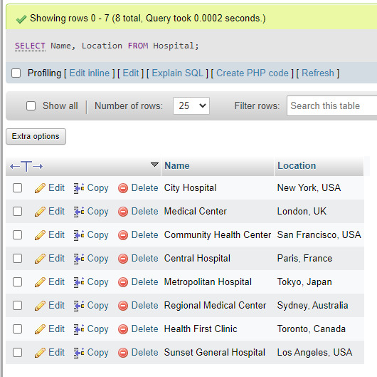

(2) SELECT AVG(Rating) AS Avg_Rating FROM Hospital;
Explanation:

This query calculates the average rating of all the hospitals in the ‘Hospital’ table. Using the AVG function, it calculates the average of the given set of values for each hospital and assigns the alias ‘AVG_Rating’ to the average rating, which is then displayed in the output.
Output:
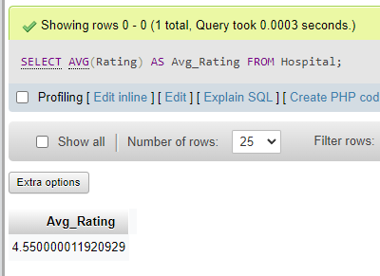

(3) SELECT Name, Rating
FROM Hospital
WHERE Rating > (SELECT AVG(Rating) FROM Hospital);
Explanation:

This SQL query selects the name and rating of all hospitals from the ‘Hospital’ table that have a higher rating than the average rating of all hospitals. It uses a subquery to compare the ratings of each hospital with the average rating of all hospitals and calculates the average rating of all the hospitals. Once this query is executed, it returns the name and rating of each hospital that has a rating higher than the average rating.
Output:
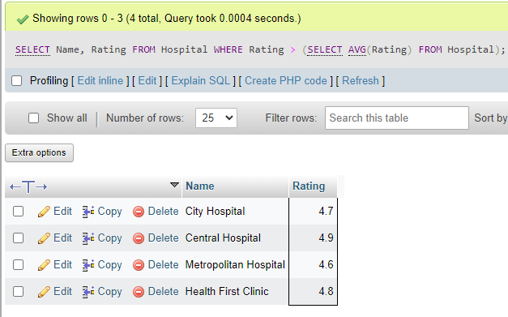

(4) SELECT Doctor.Name AS Doctor_Name, Hospital.Name AS Hospital_Name
FROM Doctor
INNER JOIN Hospital ON Doctor.Hospital_ID = Hospital.Hospital_ID;
Explanation:

Using the inner join operation, this query joins the ‘Hospital’ and ‘Doctor’ tables based on the ‘Hospital_ID’ column and retrieves the names of each doctor along with the name of the hospital which they work at.
Output:
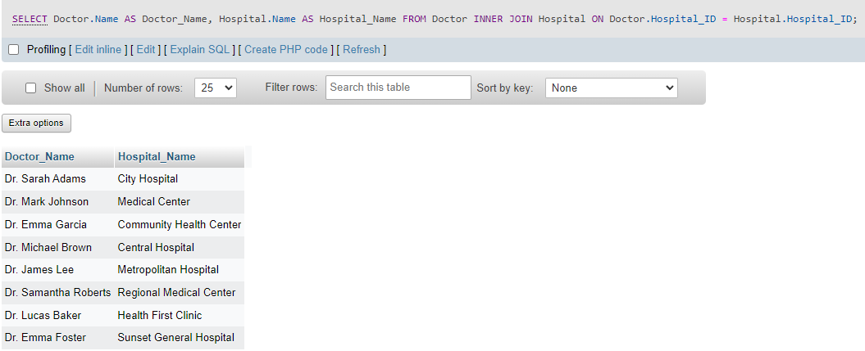

(5) SELECT Hospital.Hospital_ID, Hospital.Name AS Hospital_Name, SUM(Equipment.Amount) AS Total_Equipment_Amount
FROM Hospital
LEFT JOIN Equipment ON Hospital.Hospital_ID = Equipment.Hospital_ID
GROUP BY Hospital.Hospital_ID, Hospital.Name
Explanation:

This query retrieves the name and ID of each hospital and the total amount of equipment for each hospital from the ‘Hospital’ and ‘Equipment’ tables.
Output:
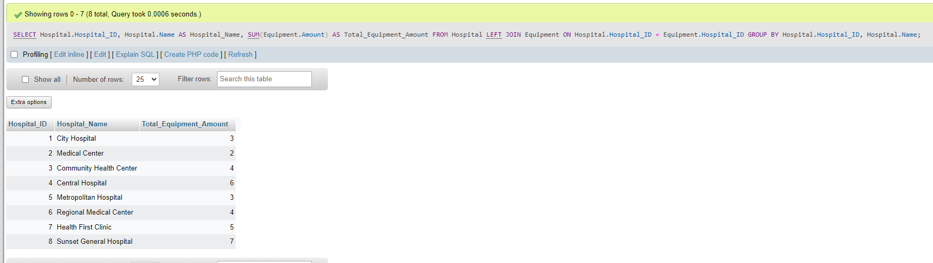

(6) SELECT Equipment_ID, ImagingType AS EquipmentType FROM Imaging
UNION
SELECT Equipment_ID, SurgicalType AS EquipmentType FROM Surgical
Explanation:
This query merges both of the subclasses (‘ImagingType’ and ‘SurgicalType’) into one table and, once executed, returns the equipment ID and its type (with duplicate entries removed).
Output:
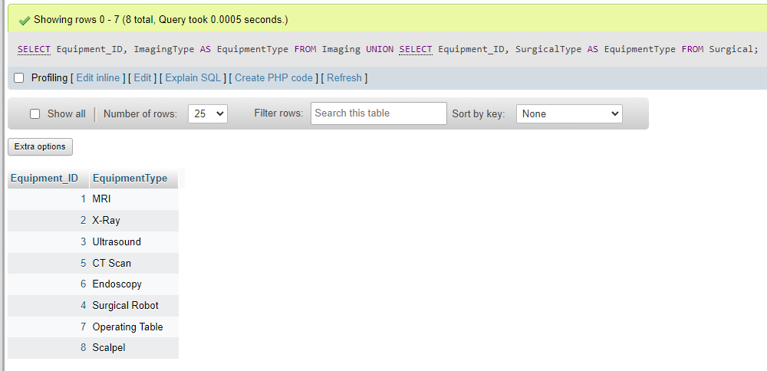

(7) SELECT Appointment_ID, Date, Room, Doctor.Name AS Doctor_Name, Hospital.Name AS Hospital_Name
FROM Appointment
INNER JOIN Doctor ON Appointment.Doctor_ID = Doctor.Doctor_ID
INNER JOIN Hospital ON Doctor.Hospital_ID = Hospital.Hospital_ID;
Explanation:

This SQL query combines data from three tables (‘Appointment’, ‘Doctor’, and ‘Hospital’) in order to retrieve data about appointments, along with doctor and hospital details.
Output:
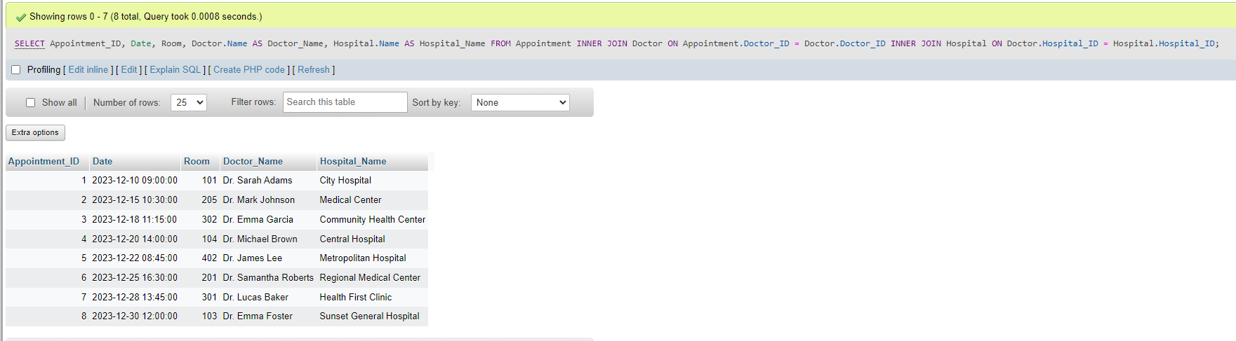

(8) SELECT DISTINCT Patient.Name AS Patient_Name
FROM Patient
INNER JOIN Appointment ON Patient.Patient_ID = Appointment.Patient_ID
INNER JOIN Doctor ON Appointment.Doctor_ID = Doctor.Doctor_ID
WHERE Doctor.Specialization = “Pediatrician”;
Explanation:

This SQL query retrieves the names of patients who have an appointment scheduled with a pediatrician. Results are filtered based on the ‘Specialization’ column in the ‘Doctor’ table.
Output:
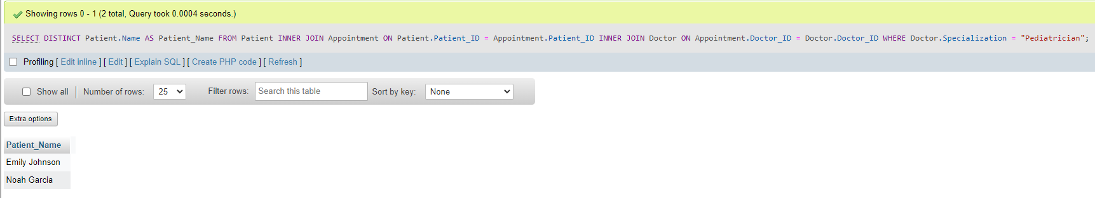

(9) SELECT DISTINCT H1.Name
FROM Hospital H1
INNER JOIN Hospital H2 ON H1.Name = H2.Name
WHERE EXISTS (
SELECT *
FROM Doctor D
INNER JOIN Appointment A ON D.Doctor_ID = A.Doctor_ID
WHERE D.Hospital_ID = H1.Hospital_ID
) AND EXISTS (
SELECT *
FROM Doctor D
INNER JOIN Appointment A ON D.Doctor_ID = A.Doctor_ID
WHERE D.Hospital_ID = H2.Hospital_ID
);
Explanation:

This query returns the names of hospitals that have at least one doctor with scheduled appointments in the database.
Output:
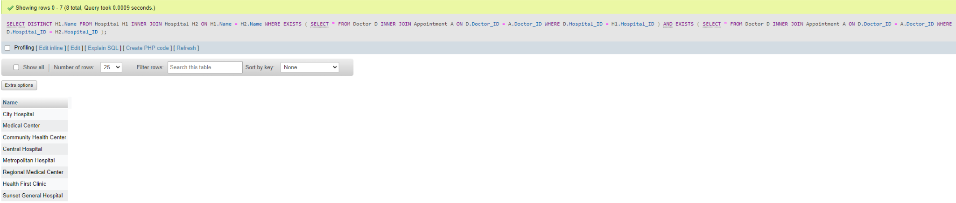

Conclusion
To conclude, the hospital database can be applied to medical information systems to optimize healthcare operations, enhance patient care, and make resource allocation among hospitals more efficient. This comprehensive design incorporates tables for hospitals, doctors, patients, appointments, and medical equipment, resulting in a solid framework for information administration within hospitals.

Each table’s data items have been carefully chosen to provide smooth operations, effective resource management, and organized, individualized patient care. The database design, as represented by the UML diagram and SQL implementation, depicts the complex interactions and dependencies between entities, resulting in a clear and ordered structure for data storage and retrieval.

The medical database’s adaptability is reflected in a wide range of queries, which range from simple data extraction to complicated joins across several tables. These inquiries demonstrate the competence and capabilities of the database, along with the system’s potential to aid decision-making, simplify data processing, and provide insights into numerous elements of healthcare management.

Overall, the hospital database has the potential to become an integral tool for the healthcare industry, able to adapt to changing needs and technologies as the medical industry grows. The design and use of this database contribute to ongoing efforts to improve healthcare efficiency, enhance patient outcomes, and drive innovation in the field of medical information systems.

